**Code Template:**

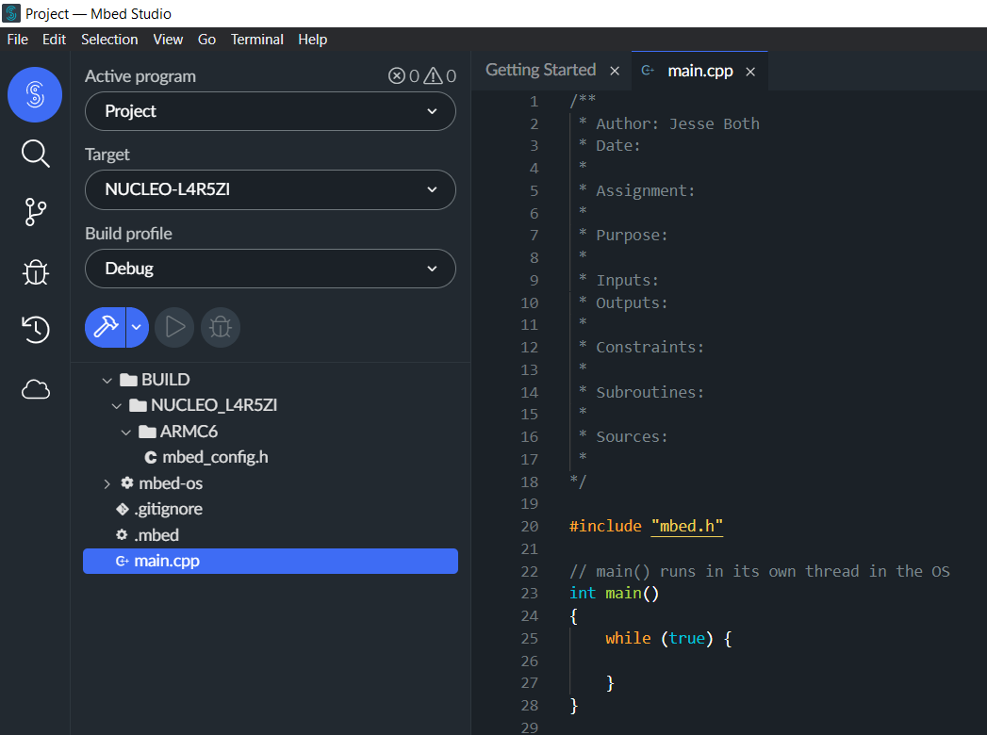

**Git:**

Username: jesseboth

**Establishing Good Planning Practices:**

**Ask**

* How close do the geese need to get to the road before the light turns red?
* What should happen if geese are stationary, but close to the road?
* Will this light be at an intersection or a 2-lane road?
* What type of sensors is best?
* Is there a better solution?
  + Tiny Helmets?

**Research/Imagine**

* The use of a proximity sensor is required to check if the geese are within range.
* A motion sensor should be used to check if geese are motionless within the range.
* It may be necessary to have some AI to determine if what the sensors are seeing is actually a goose.
* The traffic light only needs a single red bulb that is solid or blinking.

**Plan**

* Inputs
  + Geese Sensor
* Output
  + Light (blinking or solid)
* Flow Chart

